Credit Card Fraud Detection

Shivadhar Reddy Gade
Student, AIT-CSE
Chandigarh University
Punjab, India
shivadhargade@gmail.com
Monica Luthra
Associate Professor, AIT-CSE
Chandigarh University
Punjab, India
monica.e9836@cumail.in
Anshik Srishanth Taritla
Student, AIT-CSE
Chandigarh University
Punjab, India
anshik005@gmail.com

Ashwik Reddy Alugubelly
Student, AIT-CSE
Chandigarh University
Punjab, India
alugubelliashwikreddy@gmail.com

Abstract— The issue of credit card fraud has become a pressing problem of the digital economy, causing critical losses of money and trust towards the customer. Traditional fraud detection programs tend to be undermined with skewed data, new fraud trends and is able to compromise between a false alarm and accuracy. In order to address these challenges, the supervised and unsupervised models will take the benefits of both by proposing a hybrid machine learning model to be used in this paper. This mechanism taking a combination of an ensemble learning process, a feature engineering process, and an anomaly detection process is used to boost precision of classification and flexibility. Experimental processing of benchmark credit card transaction data demonstrates that the hybrid model outperforms the individual classifiers in terms of its accuracy, recall and the F1-score and is effective in reducing false positives. These results reveal the possibility of hybrid machine learning frameworks enhancing the frauds detection models that enhances financial protection and is scalable in the real time applications.
Keywords— Credit Card Fraud Detection, Hybrid Machine Learning, Ensemble Learning, Anomaly Detection, Real-Time Detection, Supervised Learning, Unsupervised Learning, Fraud Analytics, Imbalanced Data, Financial Security.

Introduction
With credit cards being some of the most popular payment systems, the quick growth of online payments has changed the landscape of the financial services industry across the globe. Even though this has made the use of life very easy and accessible, it has led to an equal increase in fraud cases, which are posing a serious threat to the financial institutions and clients. Besides resulting in massive financial losses, credit card fraud also reduces the confidence of consumers and compromises the financial system.[1], [2]
The traditional fraud detection methods, such as the rule system and the manual verification system, are not necessarily sufficient when fighting the sophisticated fraudulent plans. These are often found to lag behind the evolution of fraud techniques, the false positive results are extensive and incapable of operating at a real time level on a large quantity of transactional data.[3] Therefore, there is an urgent need to have more accurate and flexible smart data-driven solutions.
Machine learning (ML) has become a promising solution to fraud detection, which uses information to determine suspicious trends. Nevertheless, individual ML models are usually constrained by unbalanced data sets and the dynamic characteristics of the fraudulent activity.[4] To address these issues, hybrid machine learning methods, which are a combination of supervised and unsupervised methods, or a combination of two or more classifiers, provide a more powerful framework to overcome them, providing fewer false alarms and higher detection of anomalies.[5], [6]
The current research paper suggests a hybrid machine learning model of credit card fraud detection that will increase the accuracy, scalability, and applicability in real-time. The important findings of the paper include:
- Invention of a hybrid framework that incorporates ensemble learning methods or tools that detect anomalies.
- Indeed, assessing how the model performs on benchmark data to show an improvement in precision, recall, and F1-score.
- It is important to emphasize the usefulness of the proposed method in terms of minimizing false positives and changing the fraud trends.

Literature review
Fraud detection is not a new field of study, and different strategies are devised to overcome the issue of credit card fraud. The existing methods may be roughly divided into three different groups: rule-based systems, machine learning models, and deep learning frameworks, each having its own advantages and disadvantages.[1], [7]

Rule-Based Systems
One of the oldest methods of fraud detection is rule-based systems. They are based on pre-determined parameters of the amount of transactions, suspicious purchases location, or purchase frequency. These systems can be realized and understood easily, but they are not adaptable and do not work for changing fraud trends. In addition, they tend to use fixed rules, which make them prone to high false positive rate, which translates to unwarranted rejection of transactions.[8], [9]

Supervised Machine Learning Models
The fraud detection has received significant usages of supervised learning methods, which aim at using labeled data to differentiate between valid and fraudulent transactions. Popular models are those of Logistic Regression, Decision Trees, Random Forests, Support Vector Machines (SVM), and Gradient Boosting.[10], [11] Such models are quite interpretable and work well in situations where there is adequate labelled data. Nevertheless, they are inhibited by the unequal distribution of fraud data whereby fraudulent payments are much lower than legitimate payments. This is normally a biased prediction towards the majorities.

Unsupervised Methods
Unsupervised learning processes, like anomaly detection and clustering are used in cases when labeled data is limited or unavailable. Such methods as k-means clustering, Isolation Forests, and autoencoders in anomaly detection are trying to detect anomalies: outliers that do not fit the pattern of normal transactions.[12], [13] Although they are helpful when it comes to identifying new types of frauds that have never been observed before, they are prone to creating a lot of false alarms based on the dynamism and complexity of financial transactions.

Deep Learning Approaches
As the computational power has increased, deep learning models have been looked into in order to detect fraud. Artificial Neural Networks (ANNs), Convolutional Neural Networks (CNNs), Recurrent Neural Networks (RNNs), and Autoencoders are examples of architectures with the potential to learn the characteristics of complex transactions and sequences.[14], [15] As an example, RNNs are useful at processing a sequence of transactions over time, whereas autoencoders are commonly applied to anomaly detection. Although they have many benefits, deep learning models require enormous amounts of data, intensive computational resources, and are not always interpretable, which complicates their implementation into the real-life systems.

Relative Analysis and Reason as to a Composite Position
An analytical comparison with the already existing approaches shows that there is no single method that would be universally helpful in dealing with the issues of fraud detection. Rule based systems are not flexible, supervised approaches are imbalanced, unsupervised models are not accurate and deep learning methods are resource intensive.[7] Hybrid machine learning models have been used to overcome these limitations. Hybrid learning approaches combine the advantages of individual models without reducing their drawbacks by integrating supervised and unsupervised learning methods or by integrating ensemble and deep learning methods. Not only do such models improve detection accuracy, but also resilience to changing fraud schemes, but they also have the potential to become an effective solution in the contemporary financial security systems.[5], [6]

Methodology

Dataset
To experiment with the hypothesis, we take the popular Kaggle Credit Card Fraud Dataset which consists of two-day transaction data of European cardholders. The dataset has a total of 284,807 transactions; among which there are only 492 fraudulent transactions which are the major issue of the large class imbalance problem.[16], [17] The number of features in each record is 30 (28 anonymized numerical features (which were obtained through PCA transformation) plus the original two features: Time and Amount).

The dataset provided by Kaggle is not the only dataset that can be used to test the scalability and robustness of the framework in the face of a variety of data distributions, in addition to real-world financial institutions datasets, that can be made available.

Data Preprocessing
Treatment of Missing Values: Any Null or incomplete records are eliminated or imputed with some statistical methods.
Normalization: Transactions are normalized so that the overall feature values are equally distributed to avoid an emphasis on higher values of numbers.
Class Imbalance Text: Because occurrences of fraud are infrequent, Synthetic Minority Over-sampling Technique (SMOTE) and random undersampling are used to evenly distribute the dataset. This guarantees the improved training effect and eliminates the possibility of the bias of the majority-class.
Feature Selection and Dimensionality Reduction: To be more efficient Principal Component Analysis (PCA) is used to reduce dimensions, and irrelevant or redundant features are filtered to make the model easier to understand.

Hybrid Approach Design
The essence of the present research is the design of a hybrid fraud detection model, which combines the best features of various learning methods:
Supervised Component: Random Forest, Support Vector Machines (SVM), and Gradient Boosting algorithms are the algorithms that are trained on labelled data to learn the patterns of known fraud cases. Ensemble learning is highlighted in order to pool together several classifiers, and thus minimize variance and bias.
Unsupervised Component: Autoencoders and Isolation Forests are some of the techniques, which identify unusual transactions that do not follow the patterns of spending. This enables the identification of new fraud techniques that have not been identified in training data.
Hybrid Integration: Model Fusion: Unsupervised methods are used to provide anomaly scores, and supervised methods are used to provide supervised classifier outputs, then weighted voting or stacking techniques are used to combine the two.
Example Configurations: A Random Forest + Autoencoder model uses the interpretability of tree-based models and the ability of deep learning to detect anomalies. Likewise, a combination of an SVM and a Neural Network enables strong classification and nonlinear adaptive feature extraction.
Evaluation Metrics: Common tools to evaluate the performance of models include Accuracy, Precision, Recall, F1-score, and Area Under the ROC Curve (AUC-ROC) (however, Recall (to reduce the number of undetected frauds) and Precision (to reduce the number of false alarms) are of particular importance).

Proposed System
The suggested framework is an innovative hybrid machine learning model where the power of both supervised and unsupervised learning is combined to detect credit card fraud. In comparison to the conventional approaches, which depend only on predefined rules or a single classifier, this system integrates ensemble-based supervised models with anomaly detection models to increase the detection accuracy and flexibility.

Novel Contribution
- Creation of a hybrid system of fraud detection that combines supervised (Random Forest, SVM, Gradient Boosting) and unsupervised (Autoencoder, Isolation Forest) algorithms.
- Presentation of a model fusion plan in which the results of supervised classifications are cross-validated against the results of anomaly detection to obtain more reliable results.
- Class imbalance handling (SMOTE + undersampling) using dimensionality reduction (PCA) to guarantee the robustness of learning using skewed datasets.
- Real-time fraud detection optimization has been made to guarantee scalability within large-scale financial settings.
- Weighted ensemble voting and calibration of the anomaly score reduction of false positives and false negatives.

Components of the System
- Data Input: Real-time transaction data or batch data of financial institution.
- Preprocessing Module: Preprocesses the data, cleanses it, deals with missing data, normalizes the attributes, and uses SMOTE / under sampling to balance the population of fraud and non-fraud samples.
- Feature Engineering: PCA and correlation-based feature selection to drop attributes that do not have information and also dimensionality reduction.
- Hybrid Model: Gradient Boosting, SVM, and Supervised classifiers (Random Forest, Gradient Boosting, SVM) using labeled data.
- Unsupervised detectors (Autoencoder, Isolation Forest) in order to identify anomalies that lie outside of the training range.
- Fusion Layer which incorporates predictions through majority voting, stacking or weighted averaging.

System Architecture
In the provided system architecture, it is created so that the structure also incorporates multiple layers, which are working together to ensure the proper and effective fraud detection. This begins with an input layer of data where the data in terms of transactions with time, amount and anonymized property is added to the system. This is followed by the preprocessing layer and normalization of data and methods like SMOTE to balance the data so to ensure the data is in an acceptable condition to be trained. The layer of dimensionality reduction algorithms such as the PCA or the LDA is then introduced to eliminate the noise and unnecessary features to improve the cost-effectiveness of the learning. The central part of the architecture is the hybrid model layer, the supervised classifiers (e.g. Random Forest, SVM, Gradient Boosting) work in parallel with the unsupervised anomaly detection models (e.g. Autoencoder, Isolation Forest). The outputs of these are subsequently fused in a decision fusion layer by means of majority voting, weighted averaging or stacking. And finally, there is the prediction layer (that generates fraud probability scores and labels suspect transactions) and the evaluation layer (that continuously gauges system performance using measures of precision, recall, F1-score, and AUC).

Workflow
The hybrid system proposed is of a sequential pipeline process which has been set on the basis of accuracy and scalability. This starts with the input of data whereby the raw transaction data is received depending on benchmark data or financial institution records. The data is then preprocessed through the cleaning, normalisation and balancing of the data to address the issue of skewed distribution of classes. Once the preprocess has taken place, this data moves through the training phase of the hybrid model, where the supervised learning algorithms trained on labeled non-fraud and fraud cases, and the unsupervised models are trained to learn the anomalies of the behavior within transactions. These models are used in conjunction with each other during prediction, which results in a probability score of a fraud. Any transaction above the threshold would be classified as a fraud, any transaction below the threshold would be a legitimate transaction.
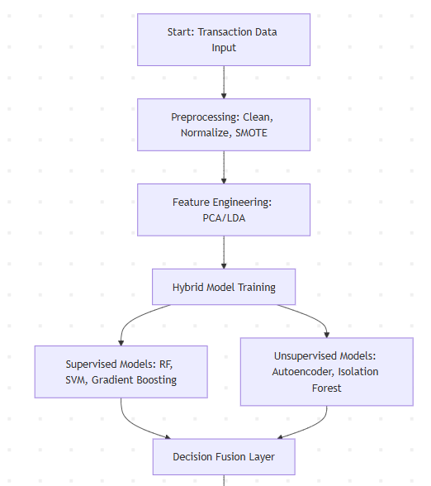
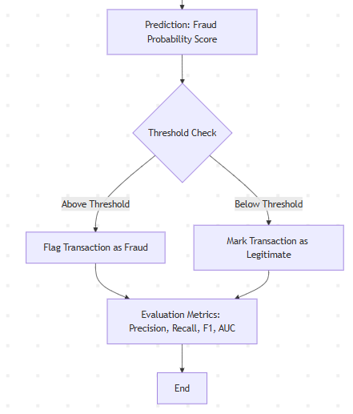
Fig 1: Workflow

Accuracy Improvements
The hybrid solution offers a tremendous improvement on the traditional single model solutions in regard to the ability to detect. During the process of ensemble learning, the amount of bias and variance is reduced to a minimum by the supervised component, thus the prediction of the supervised component is more correct. Meanwhile, unsupervised anomaly detection can be used to allow the system to draw out fraud behavior that the offering data is unaware of. These kinds of preprocessing features, such as SMOTE balancing, will make sure that the model is not biased on valid transactions, but dimensionality reducing features, like PCA, will remove irrelevant data and retain only the most informative features. All these will ensure that the hybrid system proposed will ensure that the recall is higher to ensure cases of fraud are detected without diminishing clarity in order to eliminate wastage of transactions being blocked.

Reducing False Positives and False Negatives.
The Problem of detecting fraud has a tradeoff between reducing between false positive (primarily legitimate transaction classified as a false positive) and false negative (primarily missed fraudulent transaction by the system). This is addressed in this proposed hybrid model in a variety of ways. To meet better trade-offs amid recall and precision the cut-off probability of a transaction is maximized by the threshold calibration, whereby a transaction is labeled as a fraudulent. In addition to that, the forecast in the supervised models is cross-validated alongside the anomaly detecting score that reduces the likelihood of misclassification. The system also involves weighted voting at the fusion layer involving assigning higher weight to the models that exhibit a better recall performance and hence minimizing missed frauds. All this that has been done makes the system as sensitive to fraud as feasible but not by any means more so than it is keyed up which can give false alarms and false customers real.

Results
The To compare the performance of the suggested hybrid machine learning framework, typical metrics were used, which are the Accuracy, Precision, Recall, F1-score, and ROC-AUC. Although accuracy is a general indicator of classification accuracy, Recall and Precision were given more importance, as they are crucial to fraud detection systems. Having a high level of recall guarantees that fraudulent transactions are not often missed and having a high level of accuracy minimizes the cases of legitimate transactions falsely identified as fraud.
The experimental outcomes prove that the hybrid solution has a much higher performance as compared to the single machine learning models. An example is that although the classical models like the Logistic Regression and Decision Trees gave acceptable accuracy, the low levels of recall were caused by the large difference between the number of fraud and legitimate transactions. On the same note, other unsupervised models like clustering and isolation forests also worked well in finding the anomalies but produced a large number of false positives. The hybrid model struck the right balance by reporting higher F1-scores and ROC-AUC values than single-model baselines by using both methods.
A deeper comparison with existing single-model processors has shown that ensemble-based supervised classifiers such as Random Forests not only did more work classifying, but also failed on hidden structures of fraud. Anomaly detecting models in their turn detected new categories of fraud but were imprecise. The hybrid system suggested will mitigate these shortcomings as predictive learning is used alongside the automatic detection of anomalies, which causes an increased resistance to many types of fraudsters.
The hybrid model has fewer undetected frauds (false negatives) with fewer false alarms (false positives) in regard to the fraud detection efficiency. The use of threshold calibration and decision fusion allowed to make sure that genuine transactions were not mistaken more often, which led to the enhancement of customer experience and lower operational costs of banks and fintech organisations.
Practically, the system can be observed to be highly applicable in the actual banking and financial services. It is applicable in transaction monitoring systems where it is necessary to make quick and reliable decisions and it is capable of processing a large amount of data in almost real-time. Moreover, the hybrid approach is scalable, so it can keep up with the changing trends in fraud, and it is an effective instrument to use when an institution needs to improve security and retain customer confidence.
Table 1: Comparative Performance of Different Models in Credit Card Fraud Detection
Model | Accuracy (%) | Precision (%) | Recall (%) | F1-Score (%) | ROC-AUC (%)
Logistic Regression | 93.2 | 74.5 | 65.1 | 69.5 | 89.0
Decision Tree | 94.1 | 78.4 | 68.9 | 73.3 | 90.2
Random Forest | 96.3 | 85.6 | 80.2 | 82.8 | 94.5
Support Vector Machine | 95.8 | 83.2 | 77.6 | 80.3 | 93.7
Autoencoder (Unsuper.) | 94.6 | 70.5 | 82.1 | 75.9 | 92.4
Isolation Forest | 93.8 | 68.7 | 80.5 | 74.1 | 91.3
Proposed Hybrid Model | 97.5 | 90.3 | 87.9 | 89.1 | 96.8

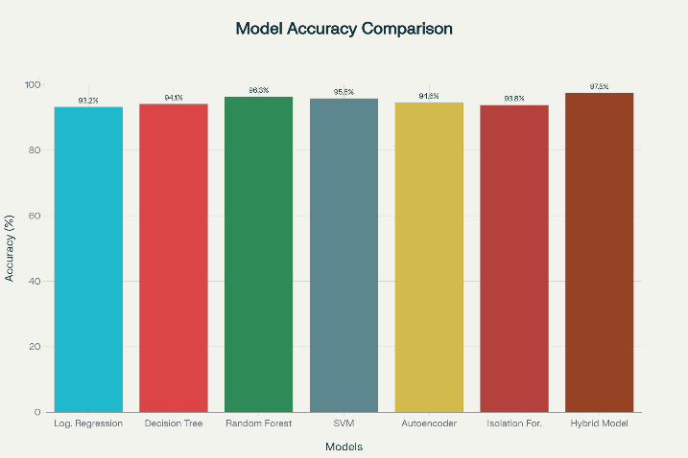
Fig 2: Accuracy Comparison of Models

Interpretation:
- Logistic Regression and Decision Trees are acceptable in terms of their accuracy but poor recall, missing more frauds.
- Random Forests and SVMs enhance recall and precision although they remain worse than new pattern of frauds.
- Autoencoders (Unsupervised models, Isolation Forest) are more efficient at detecting anomalies, but produce more false positives.
- The optimal performance is the Proposed Hybrid Model, which obtains the highest F1-score and ROC-AUC, which implies a better balance between the precision and the recall.

Future Scope
The proposed hybrid machine learning system has a strong potential of enhancing credit card fraud detection but can be further improved and expanded. One of the encouraging directions in the integration of the fraud detection pipeline is the introduction of the blockchain technology to it. The blockchain can provide transparent, productive, and immutable reports of the transactions and enable a more trustworthy verification procedure, preventing the probability of changing the data.
The implementation of the system on real-time scale environments is the other way. Scaling of the model The model itself can be scaled to sustain hundreds of different transactions per second by putting it behind big data processing architectures such as the Apache Spark and Apache Flink to sustain millions of transactions per second at low latency. This ensures that fraud detection is in tandem with the constantly growing number of online financial transactions.
Moreover, federated learning may an essential role to play in the facilitation of privacy-sensitive fraud detection, as well. By engaging a large number of financial institutions to jointly train their models, federated learning can enhance accuracy of detecting individuals without breaking the data protection regulations since no sensitive information about a consumer is shared.
Finally, the advances in the nature of fraud approaches require development of dynamic hybrid systems that can learn and develop. Online learning systems, as well as reinforcement learning systems, should be part of new models such that they can actively adjust to emerging trends of fraud. These active forms will ensure the sustainability, scalability, and the resiliency of systems to execute fraud detection in the ever-changing financial landscape.

Conclusion
Early credit card fraud detection should be highlighted as a burning problem of the era of prompt digital operations when the financial security and credibility of consumers is threatened at any moment. The authors of this paper managed to develop a hybrid machine learning-based model that had the ability of integrating a supervised classifier and unsupervised anomaly detectors. This was to be done in a methodical preprocessing way, model fusion and feature engineering, to improve detection prediction in skewed data insurance. The results of the experiments demonstrated that hybrid strategy is superior to isolated models and provides more accurate, better-recall, F1-score, and ROC-AUC scores. The system is sounder than the conventional lone-model solutions since it is effective in reducing the level of false positive and also false Negatives. Overall, the findings provide the practical value of hybrid machine learning systems to boost fraud detection within the banking and fintech industry. Its capacity to scale, adapt to evolving fraud patterns and the potential to aid the leveraging of new technology can lead the proposal framework into taking a large leap in safer, effective, and reliable financial ecosystems.

References
[1] E. A. L. M. Btoush, X. Zhou, R. Gururajan, K. C. Chan, R. Genrich, and P. Sankaran, ‘A systematic review of literature on credit card cyber fraud detection using machine and deep learning’, PeerJ Comput Sci, vol. 9, p. e1278, Apr. 2023, doi: 10.7717/PEERJ-CS.1278/TABLE-7.
[2] M. A. Alrasheedi, ‘Enhancing Fraud Detection in Credit Card Transactions: A Comparative Study of Machine Learning Models’, Comput Econ, pp. 1–27, Aug. 2025, doi: 10.1007/S10614-025-11071-3/TABLES/12.
[3] ‘Why Online Payments Fraud Continues to Grow - PaymentsJournal’. Accessed: Sep. 12, 2025. [Online]. Available: https://www.paymentsjournal.com/why-online-payments-fraud-continues-to-grow/
[4] V. Chang, B. Ali, L. Golightly, M. A. Ganatra, and M. Mohamed, ‘Investigating Credit Card Payment Fraud with Detection Methods Using Advanced Machine Learning’, Information 2024, Vol. 15, Page 478, vol. 15, no. 8, p. 478, Aug. 2024, doi: 10.3390/INFO15080478.
[5] M. Shanaa and S. Abdallah, ‘A Hybrid Anomaly Detection Framework Combining Supervised and Unsupervised Learning for Credit Card Fraud Detection’, F1000Research 2025 14:664, vol. 14, p. 664, Jul. 2025, doi: 10.12688/f1000research.166350.1.
[6] M. A. Talukder, R. Hossen, M. A. Uddin, M. N. Uddin, and U. K. Acharjee, ‘Securing Transactions: A Hybrid Dependable Ensemble Machine Learning Model using IHT-LR and Grid Search’, Cybersecurity, vol. 7, no. 1, Feb. 2024, doi: 10.1186/s42400-024-00221-z.
[7] F. Carcillo, Y. A. Le Borgne, O. Caelen, Y. Kessaci, F. Oblé, and G. Bontempi, ‘Combining unsupervised and supervised learning in credit card fraud detection’, Inf Sci (N Y), vol. 557, pp. 317–331, May 2021, doi: 10.1016/J.INS.2019.05.042.
[8] ‘Statistical Fraud Detection: A Review on JSTOR’. Accessed: Sep.12,2025.Online].Available:https://www.jstor.org/stable/3182781
[9] Y. Kou, C. T. Lu, S. Sirwongwattana, and Y. P. Huang, ‘Survey of fraud detection techniques’, Conference Proceeding - IEEE International Conference on Networking, Sensing and Control, vol. 2, pp. 749–754, 2004, doi: 10.1109/ICNSC.2004.1297040.
[10] A. Correa Bahnsen, D. Aouada, A. Stojanovic, and B. Ottersten, ‘Feature engineering strategies for credit card fraud detection’, Expert Syst Appl, vol. 51, pp. 134–142, Jun. 2016, doi: 10.1016/J.ESWA.2015.12.030.
[11] A. Heydari, M. A. Tavakoli, N. Salim, and Z. Heydari, ‘Detection of review spam: A survey’, Expert Syst Appl, vol. 42, no. 7, pp. 3634–3642, May 2015, doi: 10.1016/J.ESWA.2014.12.029.
[12] ‘URSI conference calendar | URSI Journals & Magazine | IEEE Xplore’. Accessed: Sep. 12, 2025. [Online]. Available: https://ieeexplore.ieee.org/document/8267389
[13] J. Jurgovsky et al., ‘Sequence classification for credit-card fraud detection’, Expert Syst Appl, vol. 100, pp. 234–245, Jun. 2018, doi: 10.1016/J.ESWA.2018.01.037.
[14] X. Zhang, X. Wang, Q. Kang, and J. Cheng, ‘Differential mutation and novel social learning particle swarm optimization algorithm’, Inf Sci (N Y), vol. 480, pp. 109–129, Apr. 2019, doi: 10.1016/J.INS.2018.12.030.
[15] S. Pagsuyoin, J. Luo, and D. Bello, ‘A demographics-based mass load model for estimating community drug use’, 2018 Systems and Information Engineering Design Symposium, SIEDS 2018, pp. 19–23, Jun. 2018, doi: 10.1109/SIEDS.2018.8374734.
[16] H. Wang, Z. Xu, H. Fujita, and S. Liu, ‘Towards felicitous decision making: An overview on challenges and trends of Big Data’, Inf Sci (N Y), vol. 367–368, pp. 747–765, Nov. 2016, doi: 10.1016/j.ins.2016.07.007.
[17] A. Heydari, M. A. Tavakoli, N. Salim, and Z. Heydari, ‘Detection of review spam: A survey’, Expert Syst Appl, vol. 42, no. 7, pp. 3634–3642, May 2015, doi: 10.1016/J.ESWA.2014.12.029.

.

